Bitwise Operators in JavaScript
Bitwise operators work on binary numbers (0s and 1s).
They manipulate data at the bit level.
JavaScript converts numbers to 32-bit signed integers, performs the operation, and then converts the result back to a JavaScript Number.

Why Bitwise Operators?
- Used in low-level programming, graphics, cryptography, networking, and optimization.
- Faster than arithmetic operations in some scenarios.

List of Bitwise Operators
Operator | Symbol | Description | Example (5 & 1) | Result
AND | & | Sets each bit to 1 if both bits are 1 | 0101 & 0001 | 0001 (1)
OR | | | Sets each bit to 1 if any bit is 1 | 0101 | 0001 | 0101 (5)
XOR | ^ | Sets each bit to 1 if only one bit is 1 | 0101 ^ 0001 | 0100 (4)
NOT | ~ | Inverts all the bits (1 → 0, 0 → 1) | ~0101 | -(5 + 1) = -6
Left Shift | << | Shifts bits to the left, adding zeros from the right | 5 << 1 → 1010 | 10
Right Shift | >> | Shifts bits to the right, keeping the sign bit (MSB) | 5 >> 1 → 0010 | 2
Unsigned Right Shift | >>> | Shifts bits to the right, filling zeros (ignores sign) | -5 >>> 1 | Large positive

Binary Representation Example
Decimal | Binary (4-bit)
5 | 0101
1 | 0001
4 | 0100
2 | 0010

1. Bitwise AND (&)
Returns 1 only if both bits are 1.
let a = 5; // 0101
let b = 1; // 0001
console.log(a & b); // Output: 1 (0001)
5 → 0101
3 → 0011
------------
& 0001 → 1
2. Bitwise OR (|)
Returns 1 if either bit is 1.
let a = 5; // 0101
let b = 1; // 0001
console.log(a | b); // Output: 5 (0101)
5 → 0101
3 → 0011
------------
| 0111 → 7
3. Bitwise XOR (^)
Returns 1 if bits are different, otherwise 0.
let a = 5; // 0101
let b = 3; // 0011
console.log(a ^ b); // Output: 6 (0110)
5 → 0101
3 → 0011
------------
^ 0110 → 6
4. Bitwise NOT (~)
Flips all bits and adds 1, giving the negative number.
let a = 5; // 0101
console.log(~a); // Output: -6
Formula:
~n = -(n + 1)
5 → 00000000 00000000 00000000 0000 0101
~5 → 11111111 11111111 11111111 1111 1010 → -6
5. Left Shift (<<)
Moves all bits left by a specified number of positions.
Adds zeros from the right.
let a = 5; // 0101
console.log(a << 1); // Output: 10 (1010)
Formula:
a << n = a * (2^n)
5 → 00000101
<<1 →0000 1010 → 10
6. Right Shift (>>)
Moves all bits right, keeping the sign bit (for negative numbers).
let a = 5; // 0101
console.log(a >> 1); // Output: 2 (0010)

let b = -5; // Negative number
console.log(b >> 1); // Output: -3
5 → 00000101
>>1 →00000010 → 2
7. Unsigned Right Shift (>>>)
Moves bits right, fills zeros, and ignores sign bit.
let a = -5;
console.log(a >>> 1);
// Output: 2147483645 (Large positive number)
-5 → 11111111 11111111 11111111 11111011
>>>1 →01111111 11111111 11111111 11111101 → 2147483645
Quick Comparison: >> vs >>>
Operator | Negative Number Output
>> | Keeps sign bit, stays negative
>>> | Fills with zeros, becomes positive
Real-Time Example: Checking if a Number is Even/Odd
Using bitwise AND:
function checkEvenOdd(num) {
if (num & 1) {
console.log(num + " is Odd");
} else {
console.log(num + " is Even");
}
}
checkEvenOdd(10); // Output: 10 is Even
checkEvenOdd(7); // Output: 7 is Odd
Summary
Operator | Use Case
& AND | Masking, checking bit flags
` | ` OR
^ XOR | Toggling bits
~ NOT | Inverting bits
<< Left Shift | Multiplying by 2ⁿ
>> Right Shift | Dividing by 2ⁿ (keeps sign)
>>> Unsigned Right Shift | Logical shift ignoring sign

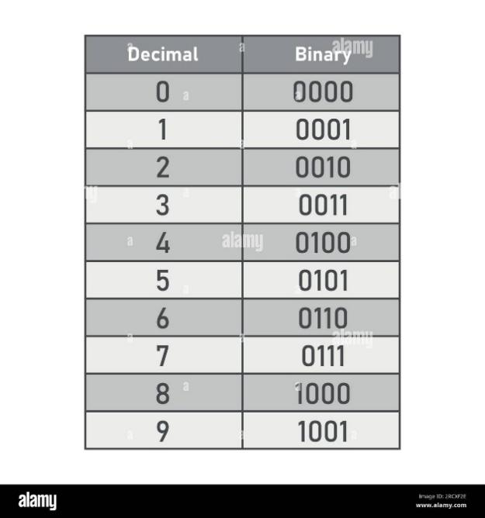
Looping in JavaScript
Loops are control structures that allow you to execute a block of code repeatedly as long as a condition is true.
They help to:
- Reduce code repetition
- Automate tasks
- Iterate through arrays, strings, objects, etc.
Types of Loops in JavaScript
Loop Type | When to Use
for loop | When the number of iterations is known.
while loop | When the number of iterations is unknown, but the condition must be checked first.
do...while loop | When the loop must run at least once, then check the condition.
for...in loop | To iterate through object properties.
for...of loop | To iterate through iterable objects like arrays or strings.
1. for Loop
Used when you know beforehand how many times you want the loop to run.
Syntax
for (initialization; condition; update) {
// Code block
}
Flowchart
- Initialize →
- Check Condition →
- Execute Code →
- Update →
- Repeat until condition is false.
Example: Print numbers from 1 to 5
for (let i = 1; i <= 5; i++) {
console.log(i);
}
// Output: 1 2 3 4 5
2. while Loop
Runs as long as the condition is true.
The condition is checked first, then the loop body runs.
Syntax
while (condition) {
// Code block
}
Example: Print numbers from 1 to 5
let i = 1;
while (i <= 5) {
console.log(i);
i++;
}
// Output: 1 2 3 4 5
🔹 Use Case: When you don’t know how many iterations are needed, like user input validation.
3. do...while Loop
Similar to while, but runs at least once, even if the condition is false.
Syntax
do {
// Code block
} while (condition);
Example: Print numbers from 1 to 5
let i = 1;
do {
console.log(i);
i++;
} while (i <= 5);
// Output: 1 2 3 4 5
🔹 Use Case: When you must execute the loop once before checking the condition, like menus or login attempts.
4. for...in Loop (Objects)
Used to iterate through properties of an object.
Syntax
for (let key in object) {
// Code block
}
Example: Iterate over object properties
const student = { name: "Alice", age: 20, grade: "A" };

for (let key in student) {
console.log(key + ": " + student[key]);
}

// Output:
// name: Alice
// age: 20
// grade: A
🔹 Use Case: Accessing keys and values of objects.
5. for...of Loop (Iterables)
Used to iterate over iterable objects, like arrays or strings.
Syntax
for (let element of iterable) {
// Code block
}
Example: Iterate over an array
const fruits = ["Apple", "Banana", "Mango"];
for (let fruit of fruits) {
console.log(fruit);
}
// Output: Apple Banana Mango
Example: Iterate over a string
let str = "JS";
for (let char of str) {
console.log(char);
}
// Output:
// J
// S
🔹 Use Case: Working with arrays, strings, and other iterables.
6. Nested Loops
A loop inside another loop.
Example: Multiplication Table
for (let i = 1; i <= 3; i++) {
for (let j = 1; j <= 3; j++) {
console.log(`${i} x ${j} = ${i * j}`);
}
}

7. break and continue
Keyword | Purpose
break | Stops the loop immediately.
continue | Skips the current iteration and moves to the next one.
Example: Using break
for (let i = 1; i <= 5; i++) {
if (i === 3) break;
console.log(i);
}
// Output: 1 2
Example: Using continue
for (let i = 1; i <= 5; i++) {
if (i === 3) continue;
console.log(i);
}
// Output: 1 2 4 5
Comparison Table
Feature | for loop | while loop | do...while loop
Condition Check | Before execution | Before execution | After execution
Runs At Least Once? | ❌ No | ❌ No | ✅ Yes
Use Case | Known iterations | Unknown iterations | Execute once, then check
Real-Time Examples
1. Validate Password (while loop)
let password;
while (password !== "1234") {
password = prompt("Enter password:");
}
console.log("Access Granted!");
2. Array Sum (for loop)
let numbers = [1, 2, 3, 4, 5];
let sum = 0;

for (let num of numbers) {
sum += num;
}
console.log("Sum = " + sum);
// Output: Sum = 15
3. Display Menu (do...while loop)
let choice;
do {
console.log("1. Add\n2. View\n3. Exit");
choice = parseInt(prompt("Enter your choice:"));
} while (choice !== 3);

console.log("Exited Program");
Summary
Loop Type | Use Case
for | Known number of iterations
while | Unknown iterations, condition checked first
do...while | Must execute once before checking condition
for...in | Iterate through object properties
for...of | Iterate through arrays, strings, and other iterables

